**Assignment - 2**

Pharma Analysis

|  |  |
| --- | --- |
| Assignment Date | 21 September 2022 |
| Student Name | ABINISHA E |
| Student Roll Number | 61771931003 |
| Maximum Marks | 2 Marks |

**Task 1: Sales By Customer**

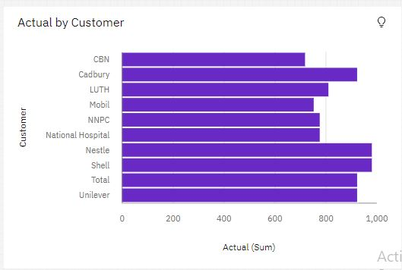

**Task 2: Sales By Location**

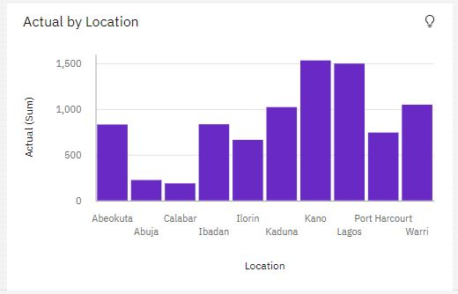

**Task 3: Sales By Sales Representative**

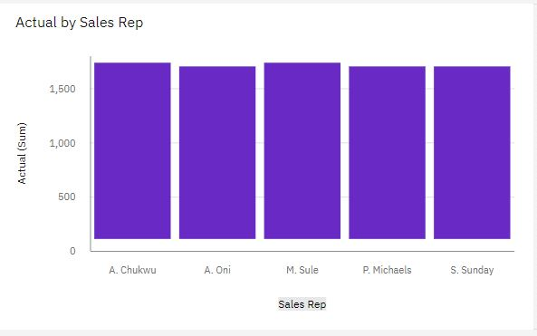

**Task 4: Received Inventory From Supplier**

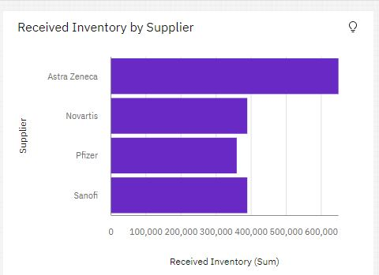

**Task 5: Inventory Stock for Warehouse Locations**

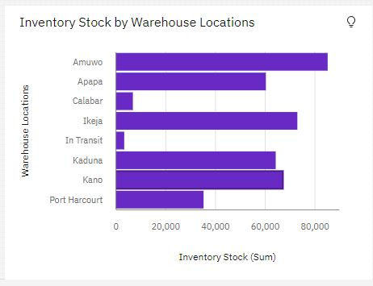

**Task 6: Sales Trend**

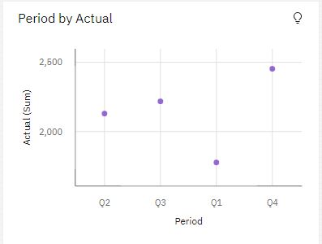

**Task 7: Monthly Sales**

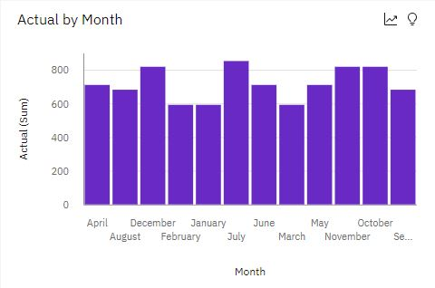

**Task 8: Actual and Received Inventory by Month﻿**

